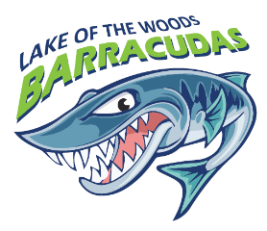
Lake of the Woods Swim Team
P.O. Box 1002
Locust Grove, VA 22508

Sponsorship Opportunities
Company/ Family Name: ____________________________________________________________
Contact name: _____________________________________________________________________
Address:___________________________________________________________________________Daytime phone number:_____________________ Email:_________________________________

Logos should be emailed (in their original format) as soon as possible to LowSwimFund@gmail.com

- Gold sponsor- $500
- 3’ x 4’ banner with logo displayed at all home meets
- Logo displayed on Main page of swim team website
- Whole page ad in the RSL Division Finals program

- Silver sponsor- $250
- 2’ x 4’ banner with logo displayed at all home meets
- Logo displayed on main page of swim team website
- ½ page ad in the RSL Division Finals program

- Bronze sponsor- $150
- 1.6’ x 3’ banner with logo displayed at all home meets
- Logo displayed on main page of the swim team website
- ¼ ad in the RSL Division Finals program

- Contributor $____________
- Logo displayed on main page of the swim team website

All sponsorships must be received by Saturday, May 25, 2024

Please submit this form, along with your payment to Low Swim Team, PO Box 1002, Locust Grove, VA 22508
Questions? Please contact Claire Schietinger, Low Swim Board Fundraising Director at LowSwimFund@gmail.com

